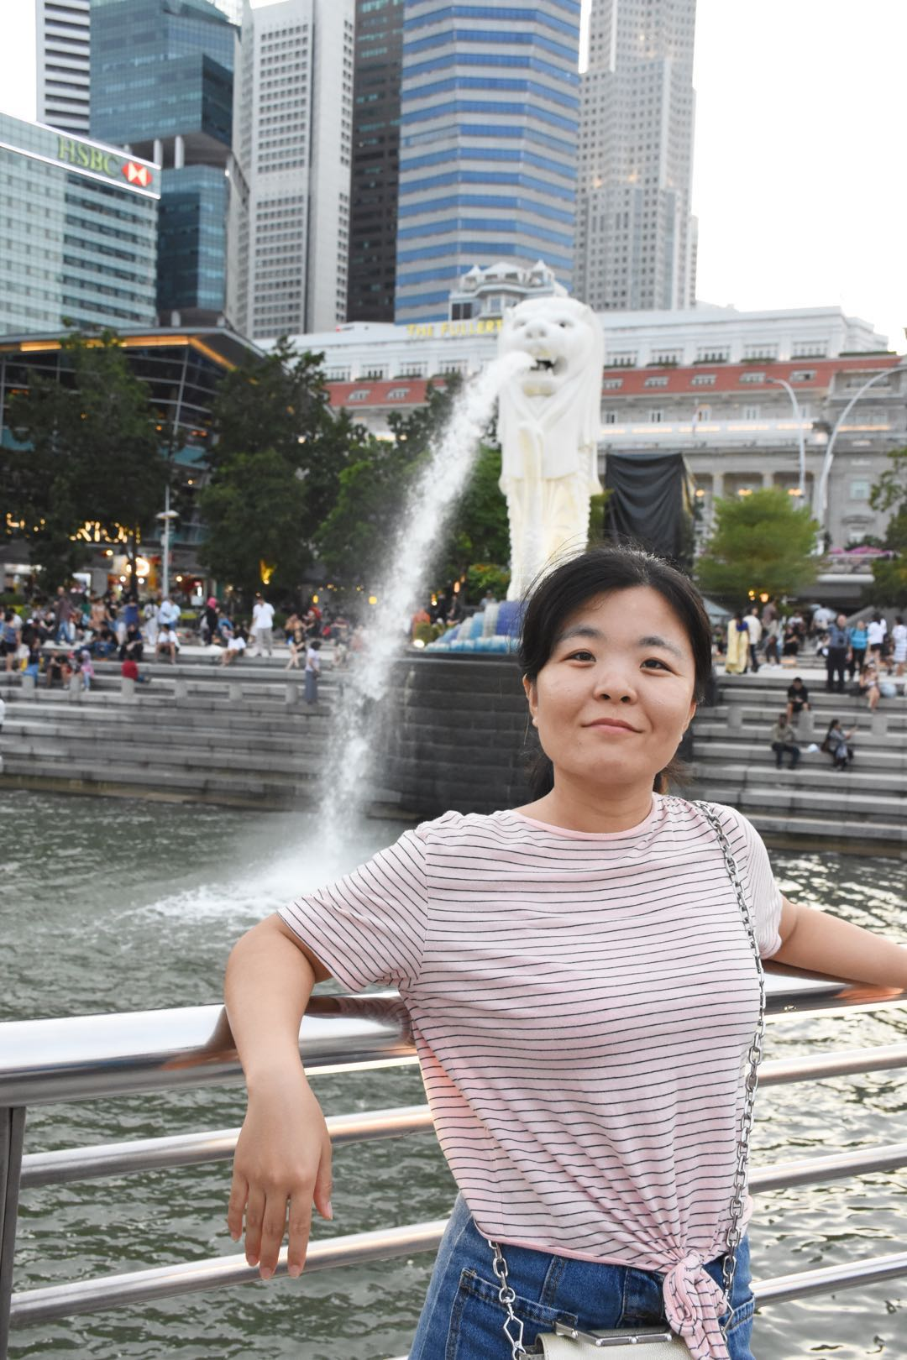  座右铭：天道酬勤，行者必至  QQ：1145325437  电话：15150506015  Email: xiaohuiliang@nuaa.edu.cn |  | 【学习与研究经历】  2016.04-至今 南京航空航天大学 博士研究生  2014.09-2016.04 南京航空航天大学 硕士研究生  2010.09-2014.06 德州学院 工学学士  【研究方向与课题】  主要研究金属有机骨架衍生多孔碳电磁波吸收材料  【研究论文与专利】  - Xiaohui Liang, et al. Self-Assembly three-dimensional porous carbon networks for efficient dielectric attenuation. ACS Appl. Mater. Interfaces 2019, 11, 30228-30233.  - Xiaohui Liang, et al. Extended effective frequency of three-dimensional graphene with sustainable energy attenuation. ACS Sustainable Chem. Eng. 2019, 7, 10477-10483.  - Xiaohui Liang, et al. Zinc oxide/nanoporous carbon hybrid materials derived from metal-organic frameworks with different dielectric and absorption performances. Inorg. Chem. Front. 2019, 6, 2521-2527.  - Xiaohui Liang, et al. Review: Recent process in the design of carbon-based nanostructures with optimized electromagnetic properties. J. Alloys Compounds 2018, 749, 887-899.  - Xiaohui Liang, et al. Nano bimetallic@carbon layer on porous carbon nanofibers with multiple interfaces for microwave absorption applications. ACS Appl. Nano Mater. 2018, 1, 5712-5721.  - Xiaohui Liang, et al. Tunable dielectric performance derived from the metal-organic framework/reduced graphene oxide hybrid with broadband absorption. ACS Sustainable Chem. Eng. 2017, 5, 10570-10579.  - Xiaohui Liang, et al. Multiple interfaces structure derived from metal-organic frameworks for excellent electromagnetic wave absorption. Part. Part. Syst. Charact. 2017, 34, 1700006.  - Xiaohui Liang, et al. Strong electric wave response derived from the hybrid of lotus roots-like composites with tunable permittivity. Sci. Rep. 2017, 7, 9462.  - Xiaohui Liang, et al. A simple hydrothermal process to grow MoS₂ nanosheets with excellent dielectric loss and microwave absorption performance. J. Mater. Chem. C 2016, 4, 6816-6821.  - Xiaohui Liang, et al. Novel nanoporous carbon derived from metal-organic frameworks with tunable electromagnetic wave absorption capabilities. Inorg. Chem. Front. 2016, 3, 1516-1526.  - Xiaohui Liang, et al. Stable Lapped Porous Co_{x}Ni_{y}@C Nanosheets with Multiple Interfaces and Magnetic Resonance Effect for Broadband Microwave Absorption in Ku Band. ACS Appl. Mater. Interfaces, 2019, submitted.  - 姬广斌、梁小会、权斌、陈家彬，一种具有MOF结构的钴镍合金-多孔碳复合吸波材料及其制备方法，南京航空航天大学。申请号：201910106896.4，公开号：CN109705808A.  座右铭：天道酬勤，行者必至  QQ：1145325437  电话：15150506015  Email: xiaohuiliang@nuaa.edu.cn  - 姬广斌，梁小会，权斌，陈家彬，一种三维多孔碳复合吸波材料及其制备方法，南京航空航天大学。申请号：201910108447.3，公开号：CN109705809A.  【主持或参与项目】  - 主持了2018年江苏省研究生科研与实践创新计划，项目编号：KYCX18_0277，项目名称：Zn, Co, Ni-MOFs制备掺杂碳基复合材料及其微波吸收性能研究。(负责人)  【学术会议与交流】  - 2019年6月参加ICMAT 材料材料工程国际学术会议，作口头报告  【获奖与荣誉情况】  - 2019年10月获得博士研究生国家奖学金  - 2018年10月获南京航空航天大学“科研创新先进个人”荣誉称号  - 2018年10月获南京航空航天大学“三好研究生”荣誉称号  【未来研究工作设想】  致力于电磁波吸收材料的研究，使其能更广泛地应用到航空航天领域。拓展研究多功能可穿戴材料。  【赠言与共勉】  多一分耕耘，多一分收获，只要付出了足够的努力，将来也一定会得到相应的收获，在科研的道路上让我们一起携手共进。

